Cluster analysis of Moneyball Dataset

Ryan Lee

MSDS411 Section 55

The Moneyball data set is a dataset that carries team statistics for baseball from the years 1871 to 2005 and normalized to a 162-game season. This dataset is intriguing as we can explore relationships that are rooted throughout the history of baseball. In this project we will exploring the hidden relationships in the data and identifying if Billy Beane, the Oakland A’s manager of Moneyball fame, that getting on base is the most important aspect of the game to allow for wins.

Moneyball is the book and film based around the Oakland A’s, a team that lost many young but expensive players to clubs with deeper pockets as Oakland is traditionally a small market. After the loss of their great players Beane and Paul Depodesta utilized analytics to craft a new team that can win baseball games. Their theory stemmed down to the game is flawed by how talent scouts choose players, with looks and other aspect playing a large part in their decisions. Instead they found cheaper players that had the ability to get on base and that would drive wins. The theory worked tremendously, and the MLB quickly adapted this strategy to bring in players to bolster there on base percentage and also drive wins. Given this dataset on based on total season statistics from such a long period of time the data needs to assessed for patterns that confirm Beane’s theories and if there are other relationships that general managers should consider when filling a baseball roster.

As we look at this data we see a relatively large dataset with 2276 entries with 16 variables not including the index. The data is summed best by showing the number of wins, Team batting statistics, team fielding statistics, and finally team pitching statistics. In regard to outlier data, given the historical nature and a lack of understanding how the game has changed i.e. more homeruns after the 1990’s, I will not remove outlier data. This data set has missing data, the first column of concern is TEAM_BATTING_HBP, since hits by pitcher is not calculable and over 90% of the statistic is missing, I am not going to include the variable for the remainder of the analysis. The remaining missing data will be added into the dataset via imputation. The proportion of missing data can be viewed below in figure 2.

Figure 1.

Figure 2.

In order to impute the data, I utilized the MICE package. MICE stands for multivariate imputation by chained equations. I utilized the method as I could test a multiple imputation method and each variable in the dataset has its own model created. As we can see in figure 3

The blue demonstrated the distribution of the original data and the purple lines are the distribution with the imputed data, as they match the original distribution well, I chose to use the random sampling method.

Figure 3

Now that we have data imputed, we will consider the correlations present in the data as referenced in figure 4. In figure 4 we see correlation throughout the data. This makes sense as most of the statistics are interlinked, as an example team homerun positively correlates to strikeouts. The example makes sense as a player needs to swing more often to hit a homerun and subsequently will strikeout more often.

Figure 4:



Next in order to correctly look at our data and not have any variable skewing any relationships the data needs normalization, this normalization was completed using the caret package. Using this package, the data maintains the general distribution but is more smoothly shaped and no variables are on a much larger scale than the others. With the data imputed and normalized we will begin look at unsupervised modelling to derive patterns in the data.

Given the large number of variables within the data set I selected to utilize PCA to see a reduction in the data and visualize any patterns in the data. First to select the correct number of principle components to look at I graphed the total variance and scree plots. Both graphs showed 5 components as a good place to start as we see the “elbow” of the scree plot, the area where the subsequent components begin to provide little benefit to the explanation. Additionally, we see at 5 components the total variance explained is almost 80% which I felt was sufficient for this analysis as we are trying to identify patterns in the data. As we see in figure 5, after component 5 we see no additional explanation to the data, and such will cut off the analysis there.

Figure 5:

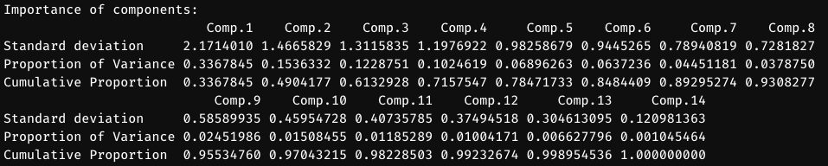

With the selection of the of the principal components we will next graph the components vs the first principal component, as we see in figure 6, we have clear clusters within the data, and these will be explored further in more analysis. As we continue to plot additional components against the first component the clusters begin to lose shape and eventually even out to a single line which does not provide additional value for this analysis.

Figure 6:

As we have seen there are clustering’s within the data, next we will explore if another clustering method can also show relationships in the data. Utilizing t-SNE, we see 4 clusters, with more average space between the clusters and similar variables within the clusters. Interestingly these variables are not the same, but the relationships viewable from the clusters demonstrate similarities for example, Homeruns and Strike outs cluster together yet again. Since the PCA yielded more distinctive cluster we will continue the analysis utilizing PCA generates clusters. As we see in figure 6, there was a decision between 4 and 5 clusters as an argument could be made for selecting either. After clustering with a k of 4 and 5, I decided to use 4 clusters as the resulting analysis made more sense with less overlap and small clusters. Utilizing the PCA clusters, we will apply K-means clustering to the graph to derive more insights from the data. We selected the number of clusters to be 4 Utilizing the first and second components we see 4 distinct cluster (figure 7). Within these clusters are in figure 8.

Figure 6:

Figure 7:

Figure 8:

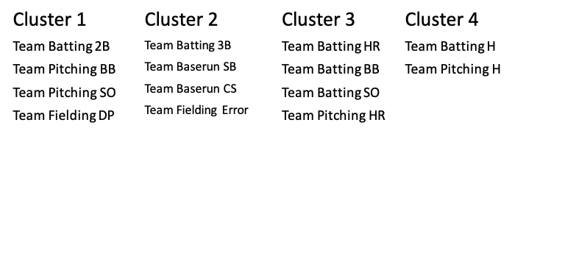

As we see in figure 8, there are some insights to be made by scouts. In cluster two we see an interesting grouping between teams hitting triple, singles, stealing and errors (TEAM_BATTING_3B, TEAM_BATTING_SB, TEAM_FIELDING_ERROR, TEAM_BASERUN_CS). This grouping provides a lot of insight into the game of baseball as hitting triples and doubles cause teams to push stealing a plate, and as result the will either result in errors (missed throw) or outs (caught stealing), while this insight is not revolutionary and will not bring about change to the game, it is fascinating to see that cluster analysis for the dataset can clearly cluster together important cause and effect relationships. This demonstrates both an effectiveness and a problem to this kind of blind analysis to the data.

Having such clear clusters in the data raised the question that are cluster able to generate actionable insight for talent scouts and method I decided to utilize was fitting linear models to the number of wins and predicting the wins. While supervised and beyond the scope of the project I felt it would provide the most insight into the effectiveness of the clusters as something that should be looked at more. To test the model, I split the data 70/30. The methodology to see the accuracy of the model was determined solely on the number of games predicted accurately. I decided that mode was “correct” if the wins predicted was within 10 games. Interestingly we saw that all four clusters performed almost identically which was not something I would have predicted. Each cluster performed between 44% and 46% accurate. This insight demonstrates something interesting based on this data. Each cluster bears the same level of importance on determining the outcome of the game and as a result these cluster do not show any significance for scouts to use as a method of determining better players for a team.

In conclusion, having such an anonymized set of data with team season stats it is harder to derive actionable insights to the game. The idea of Moneyball requires lots of data on a player basis to see the effect of a player. However, we can view relationships worth exploring for scouts with more information, like player that get on base are more likely to steal and further modeling can be completed to determine if players are more or less likely to have a positive outcome at game time. Clustering provides clues to the relationships present in the data. The model feels limited in its effectiveness showed distinct clusters, but those cluster showed relationships important to the game, and as demonstrated by the supervised linear models no one cluster is predictive of an aspect of the game that should be paid more attention to.

There is much room for future work as baseball has endless amounts of data and this project feels like a jumping off point for deriving actionable insights into the game. Some of the future work could be, in order to make better models we need more of the statistics including year to see how the game has changed. As time moves forward, the game will inevitably change, and old data could cloud new insights that would otherwise be seen as noise to the model. Or utilize additional player statistics to explore the relationships shown in the clusters and develop specific insights for use in game or select for players excellent at hitting triples and don’t force a steal. These kinds of insights could be useful to manager of baseball team in ways that can provide more wins to the team.

However, as we set out to see if Beane’s get on base was one the only significant methods of winning the analysis does not confirm or disagree with his reasoning. The results of Beane’s success at the A’s is enough to show that it does work in the game of baseball and the data available in the set does not provide enough information to see the same trends that Depodesta highlighted to Beane.

In reflection, this project provided an excellent avenue to put together a research question and explore the relationships that hidden within the data. I found it fascinating to explore data with tools learned within the quarter and see insights in the data that were not immediately apparent. I found PCA to be the most useful tool in this analysis as it quickly determined the important relationships within the data and made all the subsequent analysis possible. I think that with more data there are more insights that could be made. In the future, I would split the data and do analysis within each section of the data like batting stats or pitching stats, as we might be able to highlight the most important aspect of each part of the game as use that to generate more insights within the game, and if those cluster explore more relationships.

I am disappointed that cluster derived in my analysis did not point out a relationship that was less obvious to people. I think that this exercise in modeling taught me the most that I have done within the modeling portion of the MSDS classes as it forced utilization of the models to get insights which reflects how modelling real-world data is. I am excited to continue building models around data and determine if there are actionable insights and what those can mean to an organization. It would also be an interesting exercise to develop clusters to determine if a team was effective and label each teams year as positive or negative. The data provides many research opportunities and I look forward to continuing to explore them for fun. Thank you for an insightful quarter that challenged my modeling abilities and asked questions on how to generate a better analysis.